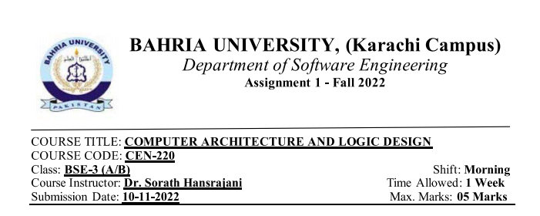

**QUESTIONS:**

1. **Describe RAM and ROM.**

**RAM:**

RAM stands for random-access memory, but what does that mean? Your computer RAM is essentially **short term memory where data is stored as the processor needs it**. This isn't to be confused with long-term data that's stored on your hard drive, which stays there even when your computer is turned off.

RAM (random access memory) is **a computer's short-term memory, where the data that the processor is currently using is stored**. Your computer can access RAM memory much faster than data on a hard disk, SSD, or other long-term storage device, which is why RAM capacity is critical for system performance.

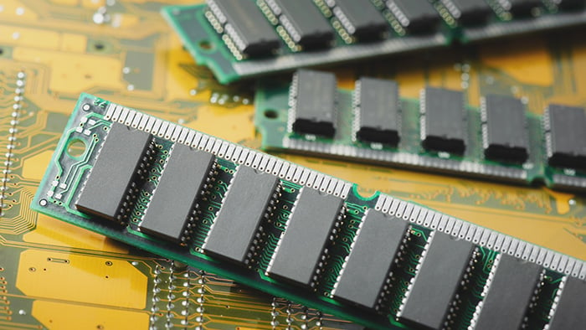

**ROM:**

Read-only memory, or ROM, is **a type of computer storage containing non-volatile, permanent data that, normally, can only be read, not written to**. ROM contains the programming that allows a computer to start up or regenerate each time it is turned on.

ROM is **an acronym for Read-Only Memory**. It refers to computer memory chips containing permanent or semi-permanent data. Unlike RAM, ROM is non-volatile; even after you turn off your computer, the contents of ROM will remain. Almost every computer comes with a small amount of ROM containing the boot firmware.

**ROM is called permanent memory:**

Because ROM is read-only, it cannot be changed; it is permanent and non-volatile, meaning it also holds its memory even when power is removed. By contrast, random access memory (RAM) is volatile; it is lost when power is removed.

ROM is further classified into four **types**- **MROM, PROM, EPROM, and EEPROM**.

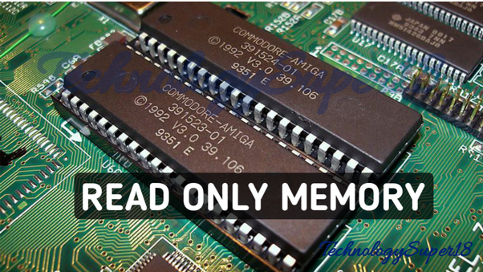

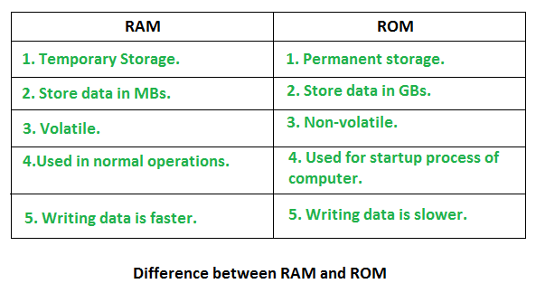

1. **Describe DRAM and SRAM and state their Differences.**

**DRAM:**

DRAM stands for “**dynamic random access memory**,” and it's a specific type of RAM (random access memory). All computers have RAM, and DRAM is one kind of RAM we see in modern desktops and laptops. DRAM was invented in 1968 by Robert Dennard and put to market by Intel® in the '70s.

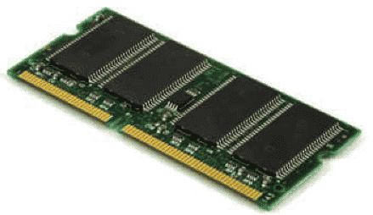

Dynamic random access memory (DRAM) is a type of semiconductor [memory](https://www.techtarget.com/searchstorage/definition/memory-card) that is typically used for the data or program code needed by a computer processor to function. DRAM is a common type of [random access memory](https://www.techtarget.com/searchstorage/definition/RAM-random-access-memory) (RAM) that is used in personal computers (PCs), workstations and servers. Random access allows the PC processor to access any part of the memory directly rather than having to proceed sequentially from a starting place. RAM is located close to a computer's processor and enables faster access to data than storage media such as [hard disk drives](https://www.techtarget.com/searchstorage/definition/hard-disk-drive) and [solid-state drives](https://www.techtarget.com/searchstorage/definition/SSD-solid-state-drive).

**SRAM:**

SRAM (static RAM) is **a type of random access memory (RAM) that retains data bits in its memory as long as power is being supplied**. Unlike dynamic RAM (DRAM), which must be continuously refreshed, SRAM does not have this requirement, resulting in better performance and lower power usage.

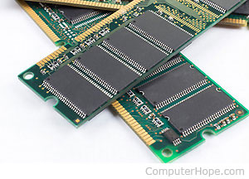

Characteristics. Though it can be characterized as **volatile memory**, SRAM exhibits data reminisce. SRAM offers a simple data access model and does not require a refresh circuit. Performance and reliability are good and power consumption is low when idle.

**Difference between DRAM and SRAM**

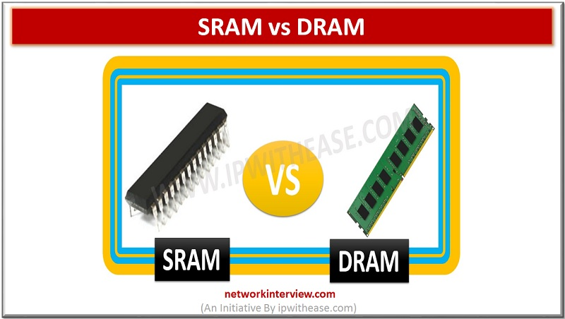

|  |  |
| --- | --- |
| **SRAM** | **DRAM** |
| It is made up of transistors | Memory cells are made up of small tiny capacitors |
| It does not need periodic refreshing to preserve the information | It need a periodic refreshing to preserve the information |
| It is much faster than DRAM | IT IS SLOWER than SRAM |
| It is more expensive than DRAM | It is cheaper than SRAM |

1. **Define and state the differences among PROM, EPROM, and EEPROM.**

**Definitions:**

**PROM:**  A permanent memory chip in which the content is created (programmed) by the customer rather than by the chip manufacturer. It differs from a ROM chip, which is created at the time of manufacture. PROMs are used for storage when their content is not expected to change, but in many applications, they have given way to EPROMs and EEPROMs, which can be reprogrammed.

**EPROM:** (erasable programmable read-only memory) is **memory that does not lose its data when the power supply is cut off**. The data can be erased and the chip reprogrammed by shining an intense ultraviolet (UV) light through a window designed into the memory chip.

**EEPROM:** A rewritable storage chip that holds its content without power. EEPROMs are byte addressable but must be erased before being rewritten.

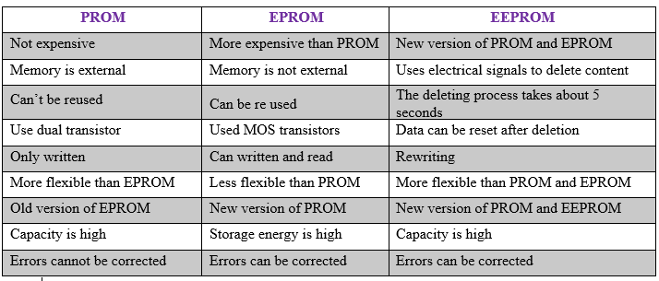

1. **Define SSD and HDD and state their differences.**

**Definitions:**

**SSD:**

A solid-state drive (SSD) is **a new generation of storage device used in computers**. SSDs store data using flash-based memory, which is much faster than the traditional hard disks they've come to replace.

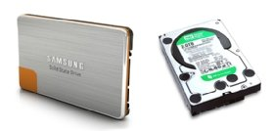

**HDD:**

A computer hard disk drive (HDD) is **a non-volatile data storage device**. Non-volatile refers to storage devices that maintain stored data when turned off.

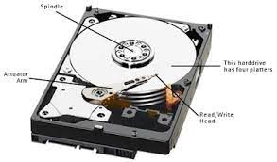

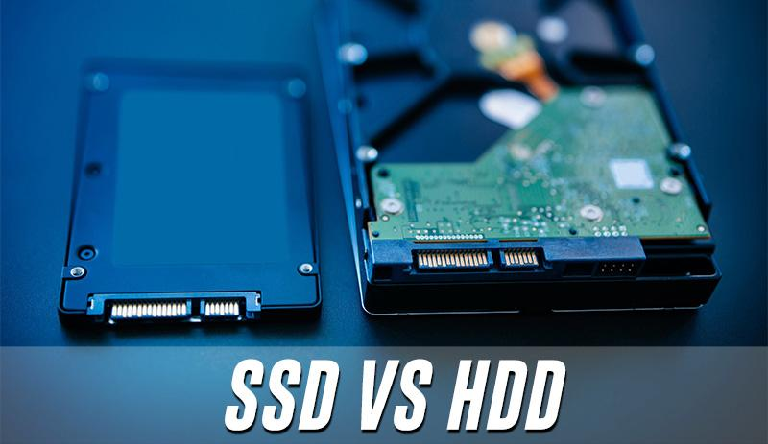

SSDs or HDDs work alongside your system's memory and processor to **access and use data**. Solid state drives use different technology than traditional hard drives that allow SSDs to access data faster, improving your computer's performance. This data includes things like your operating system, games, images, or music.

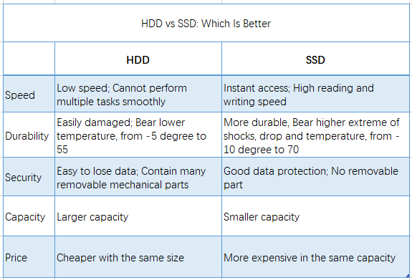

**THE END**